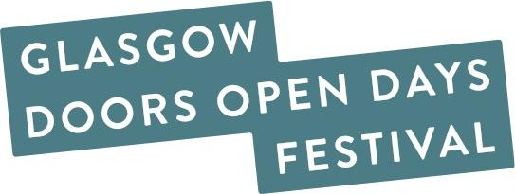

Glasgow Doors Open Days Festival 2025
Participating Venue Insurances Checklist
All venues, buildings, spaces, and sites opening their doors and welcoming in-person visits as part of the Glasgow Doors Open Days Festival 2025 must have their own Public Liability Insurance (PLI) and Employers Liability Insurance in place to participate.
Festival Dates:
Thursday 18th – Sunday 21st September 2025
As part of our festival preparations, we would very kindly like to ask all participants to complete our insurances checklist by circling or marking YES or NO next to the four questions below. Once completed please email your checklist to:
📧 doorsopendays@gbpt.org
🗓️ Deadline for checklist submissions: Monday 22nd July 2025

- Do you have Public Liability Insurance (PLI)?
☐ YES ☐ NO

- Do you have Employers Liability Insurance (EL)?
☐ YES ☐ NO

- Have you told your insurance provider you are taking part in Glasgow Doors Open Days Festival 2025 and which dates you are participating?
☐ YES ☐ NO

- Will you be completing a Risk Assessment before the festival?
☐ YES ☐ NO

Do You Need Public Liability Insurance for Your Event?
If you are not associated with a venue or organisation that covers your insurance, you may be eligible to be covered under the Scottish Civic Trust (SCT) Public Liability Insurance by registering as a volunteer.
📞 Contact:
Emily Sherriff – Doors Open Days Manager
Scottish Civic Trust
☎️ 0141 221 1466
📧 emily.sherriff@scottishcivictrust.org.uk
We know some freelance tour guides have chosen this option in previous years. Some freelance tour guides may already hold their own individual insurance that covers them for events of this nature.

Thank you for completing our Insurances Checklist ahead of taking part in Glasgow Doors Open Days Festival 2025!

