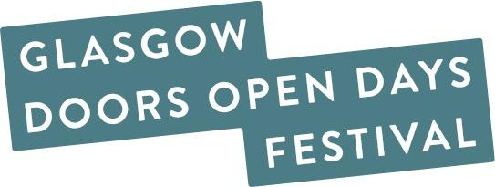

Glasgow Doors Open Days Festival 2025
Participating Venue Insurances Checklist
All venues, buildings, spaces, and sites opening their doors and welcoming in-person visits as part of the Glasgow Doors Open Days Festival 2025 must have their own Public Liability Insurance (PLI) and Employers Liability Insurance in place to participate.
Disclaimer: The organiser of the Glasgow Doors Open Days Festival 2025, the Glasgow Building Preservation Trust, accepts no liability for any accidents, incidents, or injuries incurred within or at your building, space, site, complex, or garden, or within your grounds during the duration of the festival.
We kindly ask you to confirm you have all the relevant insurances you require by marking YES or NO in the boxes provided below and sending this form us back by 22nd July. By completing this form, you will help us confirm whether you have the appropriate insurance coverage in place and whether your insurer has been notified about your participation in the festival.
Festival Dates:
Thursday 18th – Sunday 21st September 2025
If you need any help completing this form, please email or call us at:
📞 0141 554 4411
📧 doorsopendays@gbpt.org
🗓️ Deadline for checklist submissions: Monday, 22nd July 2025

- Do you have Public Liability Insurance (PLI)?
☐ YES ☐ NO

- Do you have Employers Liability Insurance (EL)?
☐ YES ☐ NO

(If you do not have Employer’s Liability Insurance, please could you give us more information about this using the box below.)

- Have you told your insurance provider you are taking part in Glasgow Doors Open Days Festival 2025 and which dates you are participating?
☐ YES ☐ NO

- Will you be completing a Risk Assessment before the festival?
☐ YES ☐ NO

Do You Need Public Liability Insurance for Your Event?
If you are not associated with a venue or organisation that covers your insurance, you may be eligible to be covered under the Scottish Civic Trust (SCT) Public Liability Insurance by registering as a volunteer.
📞 Contact:
Emily Sherriff – Doors Open Days Manager
Scottish Civic Trust
☎️ 0141 221 1466
📧 emily.sherriff@scottishcivictrust.org.uk
We know some freelance tour guides have chosen this option in previous years. Some freelance tour guides may already hold their own individual insurance that covers them for events of this nature.

Thank you for completing our Insurances Checklist ahead of taking part in Glasgow Doors Open Days Festival 2025!

